Application Due August 8, 2023
NextGen Scholarship 2023
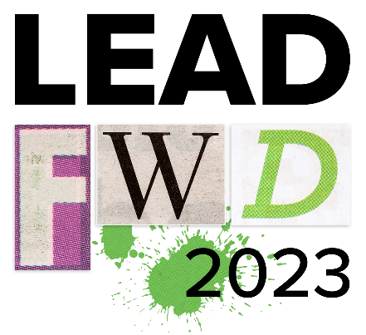
ICBA LEAD FWD SUMMIT 2023
Scholarships Available: Only one NextGen Scholarship is available. Two additional applicants will receive a John Collins Leadership Award.
NextGen Scholarship Includes: Complimentary registration (and all benefits conveyed with conference registration) to participate in ICBA’s leadership conference, the ICBA LEAD FWD Summit, Sept. 18-19, 2023 in Kansas City, Missouri. Plus, up to $1,350 in travel costs.

John Collins Leadership Award Includes: 50% discount on registration (and all benefits conveyed with conference registration) to participate in ICBA’s leadership conference, the ICBA LEAD FWD Summit, Sept. 18-19, 2023 in Kansas City, Missouri. Plus $1,000 paid to the sponsoring bank to help cover costs.

Requirements to Qualify for Scholarship and to receive funds
- Submit application by August 8, 2023
- Scholarship recipients must be a community banker employed at a community bank that is a member of both CBW and ICBA at the time the LEAD FWD Summit takes place
- Recipient must complete a post-event survey before receiving funds
- Next Gen Scholarship winner must submit receipts for travel (airfare, hotel, etc.) to qualify for reimbursement.

Application Due August 8, 2023
NextGen Scholarship 2023 Application

Bank Name:
Applicant Name:
Applicant Title:
How long has applicant been a community banker?
Question 1
Tell us about the person being nominated/applying for the scholarship:

Question 2
Is your community bank a member of both Community Bankers of Washington and the Independent Community Bankers of America (ICBA)?

Question 3
In your own words, please tell us about yourself (e.g. career path, goals, awards, hobbies, volunteer activities, etc.). Use this as an opportunity to provide insight on what makes you a great candidate for this scholarship.

Question 4
In your own words, please tell us why this scholarship will make you a better community banker. How will you use the knowledge and experience gained to improve your community bank and reach your own professional goals?

Question 5
Please tell us what you see as the biggest challenge facing community banking today and why?

Question 6
Please tell us what you see as the greatest opportunity you see in community banking today and why?

Question 7
We’re interested in learning what your leadership and/or colleagues can share about your experience in community banking and/or leadership. Please submit a letter of recommendation from an executive or officer at the bank that speaks to your character and supports your request for a scholarship?

Please email your letter of recommendation to:
Kathy Swenson – kathy@communitybankers-wa.org

